Goal | Long-term cooperation with fabrication company within Europe based on future agreement
Fabrication of product : | fan guard + small steel supporting structure
Detailed specification & dimensional drawings: | available for potential supplier after initial confirmation of proven manufacturing capability
Overall product description : | Complete scope include delivery of: fan guards in different shapes, pulley guard and small supporting steel construction for pulleys and fan ring
Anti corrosion protection - HDG | Supplier shall be ready to provide HDG as corrosion protection according the EN1461 lub ASTM A153
Material grade for guards and steel structure | Standard S235JR (for supporting structure, wire netting stich (for guards)
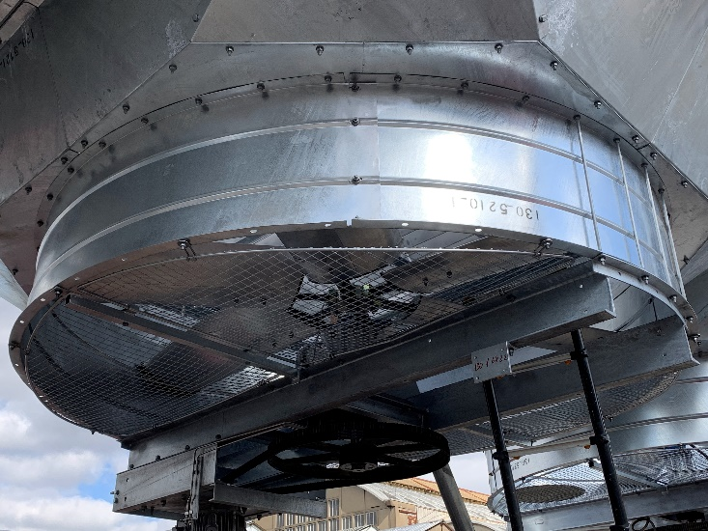  Product example pictures | 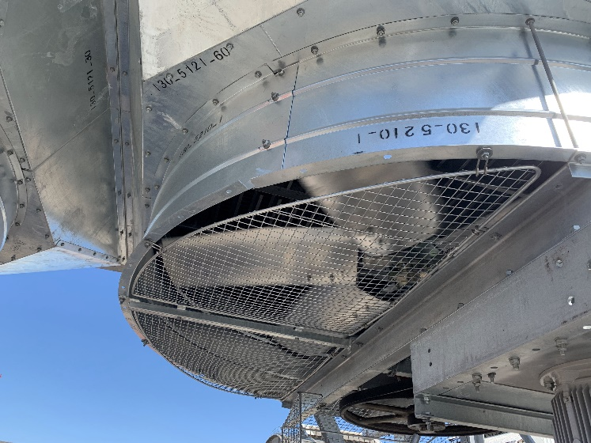
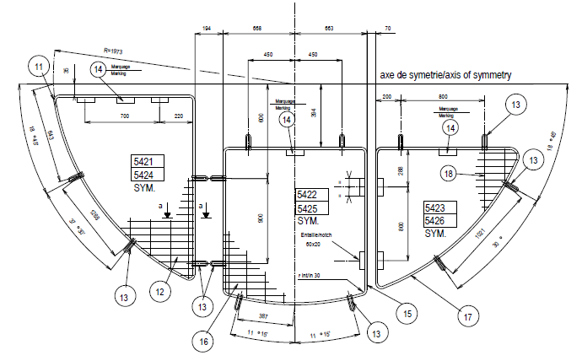 | 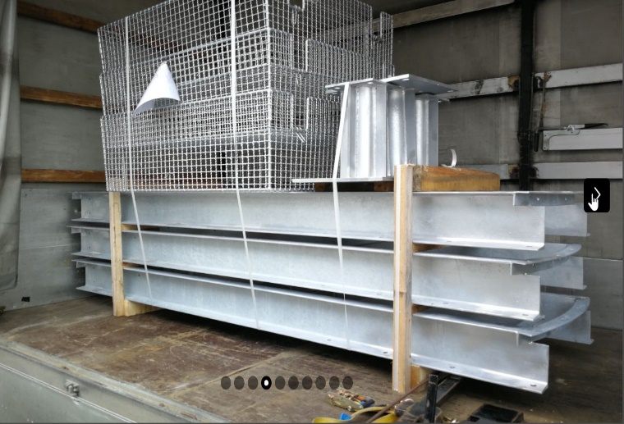
Other requirements | Supplier well comunicating in English language, ideally conforming wih ISO9001 and EN1090
Incoterms: | To be agreed
Payment conditions | 100% 45 days after delivery / notice for pickup
Contact : | KELVION HOLDING  Mr. Marek Sadowski  Global Commodity Manager  00 48 607 309 866

